

**System Title in English**

**System Title in Arabic (if any)**

A systems analysis and design document submitted to Khan Younis Training College for the degree of Technical Diploma as a part of the graduation project in the specialization of E-Business Program

**Prepared By:**

Razan Zourob

Nour Awad

Hamza Abu Nemer

Marah sliam

Dana Hamad

Fatima Suliman

**Supervised By:**

Raed Felfel

E-Business Program

2023 – 2024

# Acknowledgement

First of all, we are grateful to ALLAH the Almighty for all blessings in this life and for giving us power and ability that were necessary to achieve this goal. All thanks and praise belong to ALLAH “Al-hamdulillah”.

We extend our sincere thanks to those who guided us and provided us with valuable advice and advice in preparing the document, Mr. Raed Felfel and thanks to all the electronic business instructors and special thanks to our distinguished college, Khan Yunis Training College.

We also thank all the members of the team who contributed to the preparation of the document, and thanks to the team leader, Rezan Zourob, for her efforts towards us and the document.

Last but not least, we would like to express our sincere gratitude and appreciation to our parents, brothers, sisters and friends for their love, support and for tolerating the time which we spent in working our document.

# Table of Content

Acknowledgement II

Table of Content III

Table of Tables V

Table of Figures V

Abstract VII

Chapter 1 Introduction 8

1.1 System Description 8

1.2 System Objectives 8

1.2.1 Business Objectives 8

1.2.2 Team Objectives 8

1.3 Competitors Analysis 8

Chapter 2 Planning 9

2.1 Methodology 9

2.2 Initial Timeline 9

Chapter 3 Requirements Analysis 10

3.1 System Users 10

3.2 Functional Requirements 10

3.2.1 User-1 Functional Requirements 10

3.2.2 User-2 Functional Requirements 10

3.3 Non-Functional Requirements 10

Chapter 4 System Models 11

4.1 Use Cases 11

4.1.1 User-1 Use Cases 11

4.1.2 User-2 Use Cases 11

4.2 Data Flow Diagram 11

4.2.1 Context Data Flow Diagram 11

4.2.2 Level-0 Data Flow Diagram 11

4.3 Entity Relationship Diagram 11

Chapter 5 System Specification 12

5.1 The Used Technologies 12

5.2 Database Physical Model 12

5.3 Wireframes 12

5.3.1 User-1 Wireframes 12

5.3.2 User-1 Wireframes 12

# Table of Tables

Table 1: Customer signup Use Case 7

Table 2 Customer login Use Case 9

Table 3 Customer logout Use Case 10

Table 4 Customer browse categories Use Case 11

Table 5 Customer browse category items Use Case 12

Table 6 Customer Show Details Category Item Use Case 13

Table 7 Customer filter product Use Case 14

Table 8 Customer shop cart management Use Case 16

Table 9 Customer Make Order Use Case 17

Table 10 Customer send design Use Case 19

Table 11 Customer Post his/her Review Use Case 20

Table 12 Customer add comment Use Case 22

Table 13 Admin Login Use Case 23

Table 14 Admin Logout Use Case 24

Table 15 Admin Categories Management Use Case 25

Table 16 Admin Category Items Management Use Case 27

Table 17 Admin Filter Categories Use Case 29

Table 18 Admin Discount Management Use Case 31

Table 19 Admin Show Customer Comment Use Case 33

# Table of Figures

**Figure ‎2.1:** Waterfall Methodology 4

Figure 2 Context Data Flow Diagram 34

Figure 3 Level-0 Data Flow Diagram 35

Figure 4 Entity Relationship Diagram 36

Figure 5 sign up 38

Figure 6 Login 39

Figure 7 Home page 40

Figure 8 Display Category and product 41

Figure 9 Product details 42

Figure 10 Shop Cart 43

Figure 11 Payment 44

Figure 12 Design request 45

Figure 13 Settings 46

Figure 14 Login admin 47

Figure 15 Sign up Admin 48

Figure 16 Add category 49

Figure 17 Edit category 50

Figure 18 Add Product 51

Figure 19 Edit Product 52

# Abstract

The system is a platform for **Al-Fania Furniture and Decoration Company**, an electronic platform for selling furniture designed to simplify and enhance the furniture shopping experience for users. The primary goal of the system is to provide an accessible, convenient, and efficient platform for customers to browse, compare, and purchase a wide range of furniture items without the need to visit the physical store. The system addresses the growing demand for time-saving and user-friendly solutions in the furniture market, offering detailed product information, customization options, and a seamless purchasing process.

We have prepared this document to help us analyze the data and facilitate the process of creating the site where we have identified the requirements correctly and understood the requirements through the use case and data flow diagrams and we have prepared Logical entity relationship diagram to represent and organize data and relationships in the system visually.

# Introduction

## System Description

The system is a platform for **Al-Fania Furniture and Decoration Company**, an electronic platform for selling furniture designed to simplify and enhance the furniture shopping experience for users. The primary goal of the system is to provide an accessible, convenient, and efficient platform for customers to browse, compare, and purchase a wide range of furniture items without the need to visit the physical store. The system addresses the growing demand for time-saving and user-friendly solutions in the furniture market, offering detailed product information, customization options, and a seamless purchasing process.

The platform targets individuals, families, and professionals in urban areas aged 20 to 50 who are looking for furniture that suits their homes or offices, while providing a smooth and reliable shopping experience.

**Users of the system include:**

1. Customers: They can explore furniture catalogs, view product details (e.g., size, material, color), compare prices, and complete purchases using various payment methods. They also have access to delivery tracking and customer support.
2. Administrators: Responsible for managing product listings, handling orders, and addressing customer inquiries.

**Main functionalities:**

1. For Customers:

* Product search and filtering.
* Secure payment processing and order confirmation.
* Personalized recommendations based on browsing and purchase history.

1. For Administrators:

* Product management (add, edit and delete)
* Order management.
* Analytical dashboards to track sales performance.
* Customer support management to communicating with customers

## System Objectives

### Business Objectives

* Increase Sales Revenue: Maximize online sales by providing a wide range of high-quality furniture options with competitive pricing.
* Enhance Customer Experience: Offer an intuitive and user-friendly platform that allows customers to browse, customize, and purchase furniture effortlessly.
* Expand Market Reach: Target urban areas and attract customers aged 20 to 50 by utilizing effective marketing strategies and social media campaigns.
* Improve Operational Efficiency: Streamline inventory management, order tracking, and delivery systems to ensure timely and accurate service.
* Build Brand Loyalty: Establish a trusted reputation by providing reliable customer service, transparent policies, and post-purchase support.

### Team Objectives

1. Develop a User-Centric Website: Create an aesthetically appealing, responsive, and easy-to-navigate website that meets customer expectations.
2. Ensure System Reliability: Build a stable platform with minimal downtime and robust security to protect user data.
3. Collaborate Effectively: Work closely with designers, developers, and analyst to ensure the platform meets business and technical requirements.
4. Optimize Performance: Continuously monitor and improve website speed, loading times, and compatibility across devices.
5. Support Scalability: Design the platform to accommodate future growth, including additional features and a larger customer base.

## Competitors Analysis

Our website is distinguished from the Egyptian website beyooot, Strengths of Our Website:

1. Provide a section where customers can upload images and descriptions of new designs, allowing the company to customize, prepare, and deliver the requested furniture to the customer.
2. Social Media Marketing: Creating an interactive community on social media that encourages customers to share pictures of their homes and experiences, boosting brand awareness.
3. Dedicated Customer Support: we allow the customer to send comment to explain her/his problem.

# Planning

## Methodology

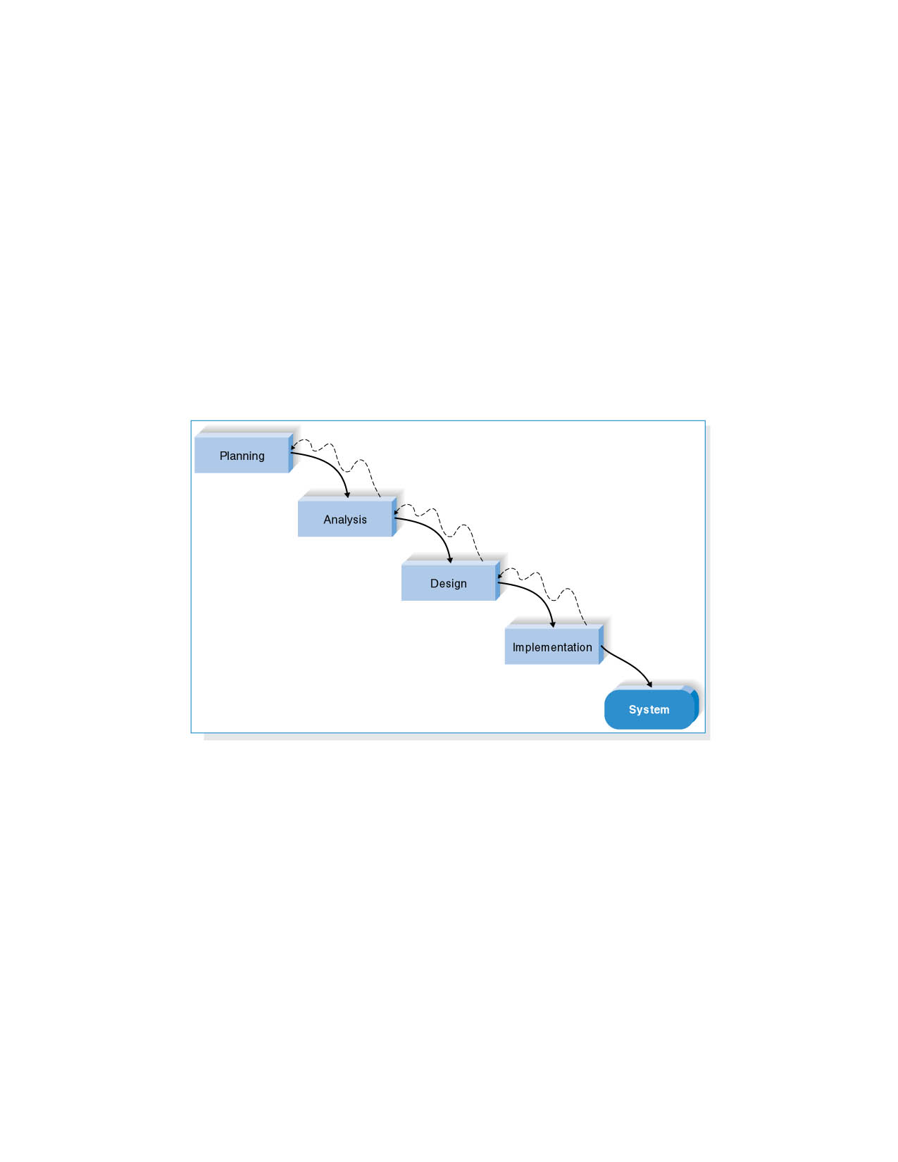

**Figure ‎2.1:** Waterfall Methodology

## Initial Timeline

* Planning (15%): 2 weeks
* Analysis (20%): 2.7 weeks = 3 weeks
* Design (35%): 4.7 weeks = 5 weeks
* Implementation (30%): 4 weeks

Total Project Duration: ~14 weeks

# Requirements Analysis

## System Users

Admin

Customer

## Functional Requirements

### Admin Functional Requirements

* The system must allow the admin to log in to the control panel.
* The system must allow the admin to log out.
* The system must allow the admin to view categories.
* The system must allow the admin to categories management.
* The system must allow the admin to category items management
* The system must allow the admin to search for categories.
* The system must allow the admin to create and manage (add, edit, delete) promotions or discounts.
* The system must allow the admin to order management (e.g., processing, shipped, delivered) and cancel or refund orders if necessary.
* The system must allow the admin to show the customer comments.
* Analytical dashboards to track sales performance.

### Customer Functional Requirements

* The system allows the customer to browse by categories (e.g., furniture, décor).
* The system allows the customer to search for specific products using a search bar.
* The system allows the customer to filter products by search result.
* The system allows the customer to sign up an account with email and password.
* The system allows the customer to log in to the system.
* The system allows the customer to log out of the system
* The system allows the customer to add feedback, evaluations, reviews or ratings for purchased products.
* The system allows the customer to send comment to explain her/his problem.
* The system allows the customer to add products to the shopping cart, edit and delete in the cart.
* The system allows the customer to add products to a Wishlist for future reference.
* The system allows the customer to selected payment methods (e.g., cash on delivery, online payment).
* The system allows to the customer to make order.
* The system allows to the customer to send photo and details of the design that the company wants to design.
* The system allows to the customer to creating an interactive community on social media that encourages customers to share pictures of their homes and experiences.

## Non-Functional Requirements

* Operational:
* The website must be responsive to all screens.
* The system can be able to work on any web browser.
* Runs on operating systems such as Android and Windows.
* Performance:
* The site should load in less than 3 seconds.
* Support more than 500 simultaneous visitors without delays.
* The system must be available 24 hours a day, 365 days a year.
* Security:
* Secure customer information.
* Encrypt payment data.
* Allow the admin only to access to customer data.
* Culture and political
* The site supports the Arabic language

# System Models

## Use Cases

### Customer Use Cases

Table : Customer signup Use Case

|  |  |  |  |  |  |
| --- | --- | --- | --- | --- | --- |
| **Use case name:** Sign up | | **ID:1** | | **Importance level: high** | |
| **Primary actor:** customer | | | | | |
| **Description:** This use case describes how customers make the sign up for the system. | | | | | |
| **Trigger**: when the customer clicks on the Signup link at the nav bar. | | | | | |
| **Type**: External Temporal | | | | | |
| **Precondition:**   * The user must be connected to the Internet. * An effective registration form must be available. | | | | | |
| **Normal Course:**   1. The customer clicks on sign up link 2. Sign up form is displayed for the customer which includes (First Name, Last Name, Username, email, password, and confirm password) 3. The customer fills in the new information 4. The customer clicks on the sign-up button. 5. You need to check if the username/email doesn’t exist. 6. add a new customer to the customer information. 7. The system redirects the customer to the home page. 8. Sign up transaction save to log customer | | | **Information for Steps**  First name, last name, username,  password, email  Customer information  New signup transaction | | |
| **Postcondition:**   * A new account is created and stored in the user database. | | | | | |
| **Extensions:**   * At step three if the customer email already exits, a message massage will be displayed “username already exit”. * At step three if the email is invalid, an error message will be displayed “please, use a valid email address”. * At step three if the password and password confirmation are not identical, an error massage will be displayed “password and confirm password should be identical”. * At step three if the password is less than 8 characters, an error massage will be displayed “please, the password should be at least 8 characters”. * If the customer didn’t fellfield any filed an error message will be displayed “please, fill in all the required fields”. | | | | | |
| **Input Description**  Username, password, first name, last name, email. | **Source**  Customer | | **Output Description**  sign up transaction  Customer information | | **Destination**  Customer information  Customer information |

Table Customer login Use Case

|  |  |  |  |  |  |
| --- | --- | --- | --- | --- | --- |
| **Use case name:** login | | **ID:2** | | **Importance level: high** | |
| **Primary actor:** customer | | | | | |
| **Description:** This use case describes how customers make login into the system. | | | | | |
| **Trigger**: when the user clicks on the login link at the nav bar. | | | | | |
| **Type**: External Temporal | | | | | |
| **Precondition:**   * Having a previously registered user account. * User's Internet connection. | | | | | |
| **Normal Course:**   1. The user clicks on the login link 2. The login form is displayed for the user 3. Ask the user to enter a username & password 4. Verify if the username and password exist in the user record. 5. Redirect the user to the home page. 6. Log in transaction save to log records | | | **Information for Steps**    username & password  Existing user  Login transaction | | |
| **Postcondition:**   * Allow the user to access his personal account. | | | | | |
| **Exceptions:**   * If the email is incorrect, it displays the message “Email is invalid” * If the password is incorrect, display the message “Password is incorrect.” | | | | | |
| **Inputs Description**  Username & password | **Source**  Customer | | **Output Description**  login transaction  Existing user | | **Destination**  Customer information  Customer information |

Table Customer Logout Use Case

|  |  |  |  |  |  |
| --- | --- | --- | --- | --- | --- |
| **Use case name:** logout | | **ID:3** | | **Importance level: middle** | |
| **Primary actor:** customer | | | | | |
| **Description:** This use case describes how customer make log out to the system. | | | | | |
| **Trigger**: when the user clicks on the log out link at the nav bar. | | | | | |
| **Type**: External Temporal | | | | | |
| **Precondition:**   * The user must have already logged in | | | | | |
| **Normal Course:**   1. The user clicks on sittings and click on log out. 2. The system asks the user if he sure log out from the system. 3. The user click ok 4. The system removes it from the site | | | **Information for Steps**      Log out transaction | | |
| **Postcondition:**   * Terminate the user session and close access to the account**.** * Saves user information. | | | | | |
| **Exceptions:**   * Connection dropped during operation: A warning appears and a retry is prompted when the connection is restored. | | | | | |
| **Inputs Description**  Logout request | **Source**  Customer | | **Output Description**  Logout transaction | | **Destination**  Customer information |

Table Customer browse categories Use Case

|  |  |  |  |  |  |
| --- | --- | --- | --- | --- | --- |
| **Use case name:** Browse categories | | **ID:4** | | **Importance level: middle** | |
| **Primary actor:** customer | | | | | |
| **Description:** This use case describes how customer browse categories. | | | | | |
| **Trigger**: when the customer enters to the site. | | | | | |
| **Type**: External Temporal | | | | | |
| **Precondition:**   * The category must be present in the database. | | | | | |
| **Normal Course:**   1. The customer enters to the site. 2. Click on the categories page 3. The system view the categories page (sofa, sleeping sets or decorations, etc.) 4. The customer moves to the categories page (sofa, sleeping sets or decorations, etc.) 5. The user clicks on selected category | | | **Information for Steps**    View the categories      category selection | | |
| **Postcondition:**   * Categories are displayed successfully | | | | | |
| **Exceptions:**   * If the category is no longer available in the database, the message “Product is no longer available” is displayed. * If the page fails to load due to a server problem, an error message is displayed. | | | | | |
| **Inputs Description**  Category selection  View the categories | **Source**  Customer  Category | | **Output Description**  Display the categories  Customer category selection | | **Destination**  Customer  Category |

Table Customer browse category items Use Case

|  |  |  |  |  |  |
| --- | --- | --- | --- | --- | --- |
| **Use case name:** Browse category items | | **ID:5** | | **Importance level: middle** | |
| **Primary actor:** customer | | | | | |
| **Description:** This use case describes how customer browse category items | | | | | |
| **Trigger**: when the Customer click on the category item list. | | | | | |
| **Type**: External Temporal | | | | | |
| **Precondition:**   * The category item must be present in the database. * The category page must be accessible | | | | | |
| **Normal Course:**   1. View Category Page 2. The customer clicks on the select category page, such as (sofa, sleeping sets or decorations, etc.) 3. view the category item list | | | **Information for Steps**  View the categories  Category selection  View the category items list | | |
| **Postcondition:**   * Category items are displayed successfully | | | | | |
| **Exceptions:**   * If the category item is no longer available in the database, the message “Product is no longer available” is displayed. * If the page fails to load due to a server problem, an error message is displayed. | | | | | |
| **Inputs Description**  Category selection | **Source**  Customer | | **Output Description**  View the categories  View the category items list | | **Destination**  Category  Category item |

Table Customer Show Details Category Item Use Case

|  |  |  |  |  |  |
| --- | --- | --- | --- | --- | --- |
| **Use case name:** Show details category item | | **ID:6** | | **Importance level: middle** | |
| **Primary actor:** customer | | | | | |
| **Description:** This use case describes how customer browse category items | | | | | |
| **Trigger**: when the Customer click on the category item. | | | | | |
| **Type**: External Temporal | | | | | |
| **Precondition:**   * The category item must be present in the database. * The category page must be accessible | | | | | |
| **Normal Course:**   1. View Category Page 2. The customer clicks on the select category page, such as (sofa, sleeping sets or decorations, etc.) 3. view the category item list. 4. The customer clicks on the select category item link. 5. The system displays the details category item that he/she wants to see. | | | **Information for Steps**  View the categories  Category selection  View the category items list  Category item selection  Show details category item | | |
| **Postcondition:**   * Category items are displayed successfully * Users can continue adding the product to the cart or continue browsing. | | | | | |
| **Exceptions:**   * If the category item is no longer available in the database, the message “Product is no longer available” is displayed. * If the page fails to load due to a server problem, an error message is displayed. | | | | | |
| **Inputs Description**  Category selection  Category item selection | **Source**  Customer  Customer | | **Output Description**  View the categories  View the category items list  Show details category item | | **Destination**  Category  Category item  Category item |

Table Customer filter product Use Case

|  |  |  |  |  |  |
| --- | --- | --- | --- | --- | --- |
| **Use case name:** Filter product by search result | | **ID:7** | | **Importance level: middle** | |
| **Primary actor:** customer | | | | | |
| **Description:** The user searches for a product in the online store by entering a keyword or product name. The system processes the request, retrieves matching products from the database, and displays the results to the user. | | | | | |
| **Trigger**: when the user clicks on the search icon at the nav bar. | | | | | |
| **Type**: External Temporal | | | | | |
| **Preconditions:**   * The user must be connected to the internet. * The website must be operational * The website must have category in its database | | | | | |
| **Normal Course:**   1. The user clicks on search icon. 2. The user enters a keyword, product name, or selects filters he wants to filter for. 3. The user clicks on the search icon. 4. The system processes the request and searches for matching products in the database. 5. The system displays a list of matching products. 6. The user can click on any product to view category item. | | | **Information for Steps**  Keyword/ product Name    Search request  filtered the products | | |
| **Alternative Flows**   1. If no results are found, the system displays a message: “No matching results found, try different search terms.” | | | | | |
| **Postconditions:**   * Search results are displayed if matching products are found * If no results are found, the user is guided to try different keywords or product name. | | | | | |
| **Exceptions:**   1. If there is an internet connection error, the system displays an error message: “Check your internet connection and try again.” 2. If there is a database issue, the system displays a message: “An error occurred during the search, place try again later” | | | | | |
| **Input Description**  Keyword/ product Name  Search request | **Source**  Customer  Customer | | **Output Description**  Filtered the products | | **Destination**  Category item |

Table Customer shop cart management Use Case

|  |  |  |  |  |  |
| --- | --- | --- | --- | --- | --- |
| **Use case name:** Shop cart management (add, delete) | | **ID:8** | | **Importance level: high** | |
| **Primary actor:** customer | | | | | |
| **Description:** This use case describes how customer shop cart management (add, delete) for later purchase. | | | | | |
| **Trigger**: when the customer clicks on the shop cart link at the nav bar. | | | | | |
| **Type**: External Temporal | | | | | |
| **Precondition:**   * The user has selected a product. | | | | | |
| **Normal Course:**   * **Add:**  1. Click on the categories page (sofa, sleeping sets or decorations, etc.) 2. View Selected Category Page 3. Click on a category item 4. View the selected item page 5. The user clicks on add to shop cart button 6. save shop cart added in the shop cart. | | | **Information for Steps**  Category selected  Shows Categories Page  Category item selected  Shows item Categories Page  Add to shop cart request  Shop cart added | | |
| * **Delete:**  The user clicks the shop cart buttonThe system view shop cart list.The user clicks Delete ButtonThe system shows customer confirmation messageClick on Confirm to delete the product  1. Delete product from shop cart. | | | Shop cart list  Shop cart deleted | | |
| **Postcondition:**   * The product is successfully added to the cart. * The user can proceed to checkout or continue shopping. | | | | | |
| **Inputs Description**  Category selected  Category item selected  Add to shop cart request | **Source**  Customer  Customer  Customer | | **Output Description**  Shows Categories Page  Shows item Categories Page  Shop cart list  Shop cart (added)  Shop cart (deleted) | | **Destination**  Category  Category item  Shop cart  Shop cart  Shop cart |

Table Customer Make Order Use Case

|  |  |  |  |  |  |
| --- | --- | --- | --- | --- | --- |
| **Use case name:** Make order | | **ID:9** | | **Importance level: high** | |
| **Primary actor:** customer | | | | | |
| **Description:** This use case describes how customer make order. | | | | | |
| **Trigger**: when the user clicks on the order link. | | | | | |
| **Type**: External Temporal | | | | | |
| **Postcondition:**   * The user must have products in the shop cart. * User must be logged in (if required). * The payment gateway must be available in the case of electronic payment. * The shipping information must be correct and complete. | | | | | |
| **Normal Course:**   1. The user clicks on the shop cart icon 2. The system display the shop cart list. 3. The user clicks on the shopping now Button. 4. The system displays the list of products in the shop cart with prices and total. 5. The system displayed make order form for the customer. 6. The user enters order details (first name, last name, email, phone, address, number of the item, color the item, choose the payment method) 7. The system checks the availability of products in the store before proceeding. 8. If the products are available, the system requests confirmation of the order by clicking on send order button. 9. Store the order in the order record | | | **Information for Steps**  Shop cart list    Order request    Product details in the shop cart    Order and customer information      Store information  Order record | | |
| **Postcondition:**   * If the payment is successful, the order is confirmed and sent to the shipping department. * If the user chooses to pay upon receipt, the order is confirmed without the need for electronic payment processing * The order status is updated in the system. | | | | | |
| **Exceptions:**   * The electronic payment failed; the system displays the “Unable to pay, please try again or use another payment method” message. * One of the products is not available on request, the user is notified to remove the product from the cart or choose an alternative, the system display the “the product is not available” message. * Error processing the request due to a server issue, the system displays the “Error while the request was processed, please try later” | | | | | |
| **Inputs Description**  Order request  Order and customer information | **Source**  Customer  Customer | | **Output Description**  Shop cart list  Product details in the shop cart  Order record  Store information | | **Destination**  Shop cart  Category item  Order  Store |

Table Customer send design Use Case

|  |  |  |  |  |  |
| --- | --- | --- | --- | --- | --- |
| **Use case name:** Send design | | **ID:10** | | **Importance level: high** | |
| **Primary actor:** customer | | | | | |
| **Description:** This use case describes how customer send design. | | | | | |
| **Trigger**: when the user clicks on the send design link. | | | | | |
| **Type**: External Temporal | | | | | |
| **Precondition:**   * The user must be registered in the system * The device must be connected to the internet * Design image format must be acceptable (JPG, PNG, GIF, etc.) | | | | | |
| **Normal Course:**   1. The customer clicks on send design 2. The system displays design form 3. The customer enters design details in the form such as (first name, last name, email, phone, photo, size, color, fabric, choose the payment method) 4. The customer clicks on the Send design button. 5. Store the design in the design history | | | **Information for Steps**    Design information  Design record | | |
| **Postcondition:**   * The user is notified of the success of the operation. | | | | | |
| **Inputs Description**  Design information | **Source**  Customer | | **Output Description**  Design record | | **Destination**  Design information |

Table Customer Post his/her Review Use Case

|  |  |  |  |  |  |
| --- | --- | --- | --- | --- | --- |
| **Use case name:** post his/her review | | **ID:11** | | **Importance level: high** | |
| **Primary actor:** customer | | | | | |
| **Description: This** use case allows the user to submit a review of a product he bought, so that he can evaluate the product after receiving it, writing an opinion about it, and possibly add a photo or video to support its review. The system saves the review and displays it on the product page after it is validated. | | | | | |
| **Trigger**: when the user clicks on the post your experience link. | | | | | |
| **Type**: External Temporal | | | | | |
| **Precondition:**   * The user must have purchased the product * The user must be registered in the system * The product must be available in order. * The system should be able to store and view review. | | | | | |
| **Normal Course:**   1. The customer opens the page of the product he/she purchased. 2. The customer clicks on Add a review button 3. The system displays review form. 4. The customer enters experience details in the form such as (first name, last name, email, phone, photo, comment, image) . 5. The customer clicks on the Post button. 6. The system validates the review 7. Post the review on the category item details. 8. The user is notified that his review has been published. | | | **Information for Steps**  Category item details      Customer review information  Customer review record | | |
| **Postcondition:**   * The user review is saved and published on the product page. * Other users can see and interact with the review. * The user’s notification is sent to confirm the success of the transmission. | | | | | |
| **Exceptions:**   * The user has never purchased the product, it cannot be reviewed showing the “You must purchase the product before writing a review”. * A reference containing inappropriate have been sent, the system rejects it showing the “Reviewed due to inappropriate content” message. * An error occurred while sending the review due to a problem with the sever showing the “Error happened, please try later” message. * The image or video is not supported. The system requires another format. The message “The file is not supported, please upload an image in PNG or JPG format” is displayed. | | | | | |
| **Inputs Description**  Customer review information | **Source**  Customer | | **Output Description**  Category item details  Customer review record | | **Destination**  Category item  Customer review |

Table Customer add comment Use Case

|  |  |  |  |  |  |
| --- | --- | --- | --- | --- | --- |
| **Use case name:** add comment | | **ID:12** | | **Importance level: middle** | |
| **Primary actor:** customer | | | | | |
| **Description:** This use case describes how the customer adds a comment | | | | | |
| **Trigger**: when the Customer click on the link to add a comment. | | | | | |
| **Type**: External Temporal | | | | | |
| **Precondition:**   * The user must be registered in the system * The device must be connected to internet * The user must have an actual problem that needs to be addressed * The comment reception system should be active on the site | | | | | |
| **Normal Course:**   1. The user clicks on sittings 2. The user clicks on add comment 3. The user writes commentary in the writing box 4. The user sends a comment by pressing the Send Button 5. The comment appears on the comments page at admin   . | | | **Information for Steps**  Add comment        Customer comments | | |
| **Postcondition:**   * The problem is recorded and sent to the technical admin team. * The user receives a notification confirmation of the problem * The admin team can review. | | | | | |
| **Exceptions:**   * An error occurred while sending the comments due to a problem with the sever showing the “Error happened, please try later” message. | | | | | |
| **Inputs Description**  Add comment | **Source**  Customer | | **Output Description**  Customer comments | | **Destination**  comment |

### Admin Use Cases

Table Admin Login Use Case

|  |  |  |  |  |  |
| --- | --- | --- | --- | --- | --- |
| **Use case name:** login | | **ID:13** | | **Importance level: high** | |
| **Primary actor:** Admin | | | | | |
| **Description:** This use case describes how admin make login into the system. | | | | | |
| **Trigger**: when the admin clicks on the login link at the nav bar. | | | | | |
| **Type**: External Temporal | | | | | |
| **Precondition:**   * Having a admin account. * Admin’s Internet connection. | | | | | |
| **Normal Course:**   1. The admin clicks on the login link 2. The login form is displayed for the admin 3. Ask the admin to enter a username & password 4. Verify if the username and password exist in the admin information. 5. Redirect the admin to the home page. 6. Log in transaction save to log records | | | **Information for Steps**    username & password  Existing admin  Login transaction | | |
| **Postcondition:**   * Allow the admin to access his personal account. | | | | | |
| **Exceptions:**   * If the email is incorrect, it displays the message “Email is invalid” * If the password is incorrect, display the message “Password is incorrect.” | | | | | |
| **Inputs Description**  Username & password | **Source**  admin | | **Output Description**  login transaction  Existing user | | **Destination**  admin information  admin information |

Table Admin Logout Use Case

|  |  |  |  |  |  |
| --- | --- | --- | --- | --- | --- |
| **Use case name:** logout | | **ID:14** | | **Importance level: high** | |
| **Primary actor:** admin | | | | | |
| **Description:** This use case describes how admin make log out to the system. | | | | | |
| **Trigger**: when the admin clicks on the log out link at the nav bar. | | | | | |
| **Type**: External Temporal | | | | | |
| **Normal Course:**   1. The admin clicks on sittings and click on log out. 2. The system asks the admin if he sure log out from the system and if he wants to save his information | | | **Information for Steps**      Log out transaction | | |
| **Inputs Description**  Logout request | **Source**  Customer | | **Output Description**  Logout transaction | | **Destination**  Log customer |

Table Admin Categories Management Use Case

|  |  |  |  |  |  |
| --- | --- | --- | --- | --- | --- |
| **Use case name:** Categories management (add, edit, delete) | | **ID:15** | | **Importance level: high** | |
| **Primary actor:** admin | | | | | |
| **Description:** This use case describes how admin categories management (add, edit, delete). | | | | | |
| **Trigger**: when the admin clicks on categories management link at the nav bar. | | | | | |
| **Type**: External Temporal | | | | | |
| **Precondition:**   * The administrator must be logged in to the system. | | | | | |
| **Normal Course:**   * **Add:**  The admin clicks at categories management.The admin clicks on add categories button.The system displayed add categories form for the admin.  1. The admin enters the categories information.  The admin clicks add button.  1. save categories added in category record. | | | **Information for Steps**      Add category information        Category added | | |
| * **Edit:**  The admin clicks at categories management.  1. The system displayed the categories and select the category that the admin wants to edit it. 2. The admin clicks on edit category button  The system displayed edit category form for the admin.  1. The admin edits the categories information.  The admin clicks edit button.  1. save categories updated in category record. | | | View category    Edite category information  Category update | | |
| * **Delete:**  The admin clicks at categories management.  1. The system displayed the categories and select the category that the admin wants to delete it.  The admin clicks Delete ButtonThe system shows admin confirmation messageClick on Confirm to delete the category  1. Delete category from categories information. | | | View category  Delete request  Category deleted | | |
| **Alternative Flows:**   * If incorrect data is entered when adding or modifying: The system displays an error message explaining the problem (such as entering an incorrect price). * If you try to delete a product associated with ongoing orders: The system blocks the deletion and displays an error message. | | | | | |
| **Postcondition:**   * The product list is modified according to admin procedures. | | | | | |
| **Inputs Description**  Add category information  Edite category information  Delete request | **Source**  admin  Admin  Admin | | **Output Description**  Category added  Category update  Category deletes  View category | | **Destination**  Category  Category  Category  Category |

Table Admin Category Items Management Use Case

|  |  |  |  |  |  |
| --- | --- | --- | --- | --- | --- |
| **Use case name:** Category items management (add, edit, delete) | | **ID:16** | | **Importance level: high** | |
| **Primary actor:** admin | | | | | |
| **Description:** This use case describes how admin category items management (add, edit, delete). | | | | | |
| **Trigger**: when the admin clicks on category items management link. | | | | | |
| **Type**: External Temporal | | | | | |
| **Precondition:**   * The administrator must be logged in to the system. | | | | | |
| **Normal Course:**   * **Add:**  The admin clicks at category items management.The admin clicks on add category item button.The system displayed add category item form for the admin.  1. The admin enters the category item information.  The admin clicks add button.  1. save category item added in category item record. | | | **Information for Steps**        Add category item information      Category item record added | | |
| * **Edit:**  The admin clicks at category items management.The system displayed the categories and select the category in which the category item that the admin wants to edit it.The system displayed the category items and select the category item that the admin wants to edit it.  1. The admin clicks on edit category item button  The system displayed edit category item form for the admin.  1. The admin edits the category item information.  The admin clicks edit button.save category item updated in category item record | | | view category    view category item  Edite category item information  Category item record update | | |
| * **Delete:**  The admin clicks at category items management.The system displayed the categories and select the category in which the category item that the admin wants to delete it.The system displayed the category items and select the category item that the admin wants to delete it.The admin clicks Delete ButtonThe system shows admin confirmation messageClick on Confirm to delete the category item  1. Delete category item from category item record. | | | view category  view category item  delete request  Category item record deleted | | |
| **Alternative Flows:**   * If incorrect data is entered when adding or modifying: The system displays an error message explaining the problem (such as entering an incorrect price). * If you try to delete a product associated with ongoing orders: The system blocks the deletion and displays an error message. | | | | | |
| **Postcondition:**   * The product list is modified according to admin procedures. | | | | | |
| **Inputs Description**  Add category item information  Edite category item information  delete request | **Source**  Admin  Admin  Admin | | **Output Description**  Category item record (added)  Category item record (update)  category item record (deleted)  view category  View category item | | **Destination**  Category item  Category item  Category item  Category  Category item |

Table Admin Filter Categories Use Case

|  |  |  |  |  |  |
| --- | --- | --- | --- | --- | --- |
| **Use case name:** Filter product by search result | | **ID:17** | | **Importance level: middle** | |
| **Primary actor:** admin | | | | | |
| **Description:** The admin searches for a product in the online store by entering a keyword or product name. The system processes the request, retrieves matching products from the database, and displays the results to the user. | | | | | |
| **Trigger**: when the user clicks on the search icon at the nav bar. | | | | | |
| **Type**: External Temporal | | | | | |
| **Preconditions:**   * The admin must be connected to the internet. * The website must be operational * The website must have category in its database | | | | | |
| **Normal Course:**   1. The admin clicks on the search icon. 2. The admin enters a keyword, product name, or selects filters he wants to filter for. 3. The admin clicks on the search icon. 4. The system processes the request and searches for matching products in the database. 5. The system displays a list of matching products. 6. The admin can click on any product to view category item. | | | **Information for Steps**  Keyword/ product Name    Search request  filtered the products | | |
| **Alternative Flows**   1. If no results are found, the system displays a message: “No matching results found, try different search terms.” | | | | | |
| **Postconditions:**   * Search results are displayed if matching products are found * If no results are found, the admin is guided to try different keywords or product name. | | | | | |
| **Exceptions:**   1. If there is an internet connection error, the system displays an error message: “Check your internet connection and try again.” 2. If there is a database issue, the system displays a message: “An error occurred during the search, place try again later” | | | | | |
| **Input Description**  Keyword/ product Name  Search request | **Source**  Admin  Admin | | **Output Description**  Filtered the products | | **Destination**  Category item |

Table Admin Discount Management Use Case

|  |  |  |  |  |  |
| --- | --- | --- | --- | --- | --- |
| **Use case name:** Discount management (add, edit, delete) | | **ID:18** | | **Importance level: high** | |
| **Primary actor:** admin | | | | | |
| **Description:** This use case describes how admin discount management (add, edit, delete). | | | | | |
| **Trigger**: when the admin clicks on discount management link. | | | | | |
| **Type**: External Temporal | | | | | |
| **Precondition:**   * The administrator must be logged in to the system. | | | | | |
| **Normal Course:**   * **Add:**  The admin clicks at discount management.The admin clicks on add discount button.The system displayed add discount form for the admin.  1. The admin enters the discount information.  The admin clicks add button.  1. save discount added in discount information. | | | **Information for Steps**    Discount information      Discount added | | |
| * **Edit:**  The admin clicks at discount management.  1. The system displayed the discounts and select the discount that the admin wants to edit it. 2. The admin clicks on edit discount button  The system displayed edit discount form for the admin.  1. The admin edits the discount information.  The admin clicks edit button.  1. save discount updated in discount information. | | | Discount information  Discount update | | |
| * **Delete:**  The admin clicks at discount management.  1. The system displayed the discounts and select the discount that the admin wants to delete it.  The admin clicks Delete ButtonThe system shows admin confirmation messageClick on Confirm to delete the discount  1. Delete discount from discount information. | | | Delete request  Discount deleted | | |
| **Postcondition:**   * Discounts are updated according to admin procedures. | | | | | |
| **Exceptions:**   * If the admin enters incorrect or incomplete data, the system displays an error message explaining the problem and requests the correction “Failed to add discount.” * If the admin enters invalid data or an expiration date, the system prevents saving until correct data is entered. The message "Failed, modify the discount" appears. * If the admin deletes the discount associated with current orders, the system prevents the deletion and displays a warning message and displays the message "Deletion failed" | | | | | |
| **Inputs Description**  Discount information  Delete request | **Source**  Admin  admin | | **Output Description**  Discount added  Discount update  Discount delete | | **Destination**  Discount record |

Table Admin Show Customer Comment Use Case

|  |  |  |  |  |  |
| --- | --- | --- | --- | --- | --- |
| **Use case name:** show customer comment | | **ID:19** | | **Importance level: middle** | |
| **Primary actor:** Admin | | | | | |
| **Description:** This use case describes how admin show customer comment. | | | | | |
| **Trigger**: when the admin clicks on the customer comment link. | | | | | |
| **Type**: External Temporal | | | | | |
| **Precondition:**   * The admin must be logged into the system. | | | | | |
| **Normal Course:**   1. The admin clicks on the customer comment link. 2. The system displays the customer comments. 3. The admin chooses a specific comment to view details. 4. The system displays the full details of the comment. | | | **Information for Steps**  Show comment request  Show customer comments    Show customer comment details | | |
| **Postcondition:**   * Comments are reviewed and appropriate action is taken. | | | | | |
| **Inputs Description**  Show comment request | **Source**  Admin | | **Output Description**  Show customer comments  Show customer comment details | | **Destination**  customer comment  customer comment |

## Data Flow Diagram

### Context Data Flow Diagram

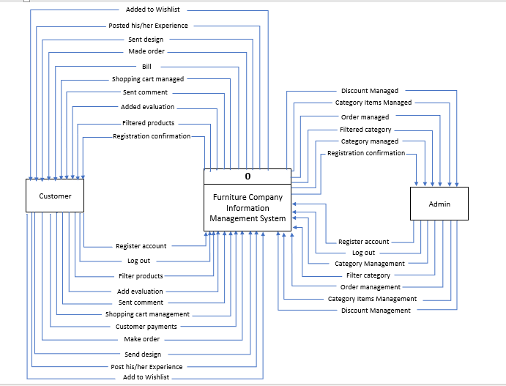

Figure Context Data Flow Diagram

### Level-0 Data Flow Diagram

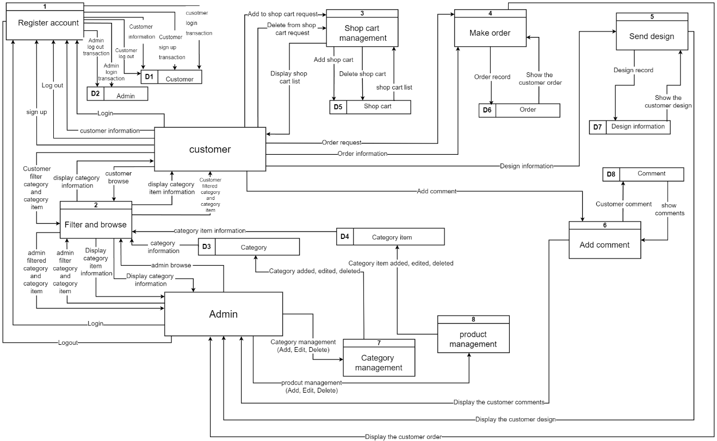

Figure Level-0 Data Flow Diagram

## Entity Relationship Diagram

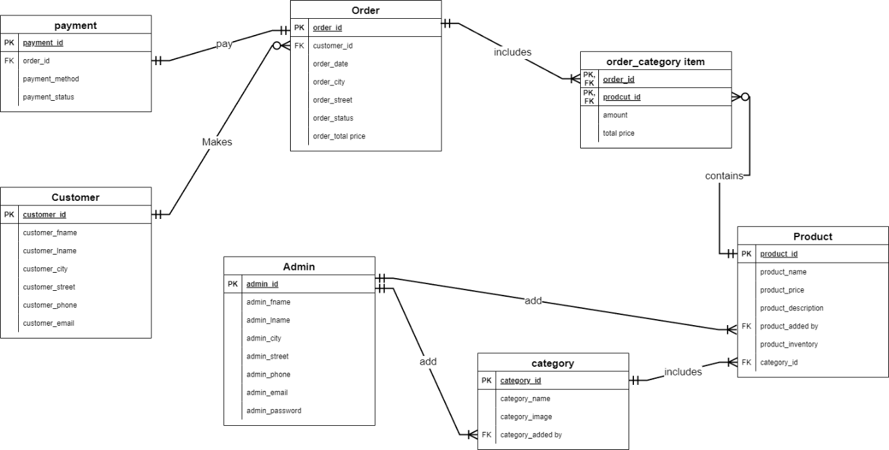

Figure Entity Relationship Diagram

# System Specification

## The Used Technologies

## Database Physical Model

## Wireframes

### Customer Wireframes

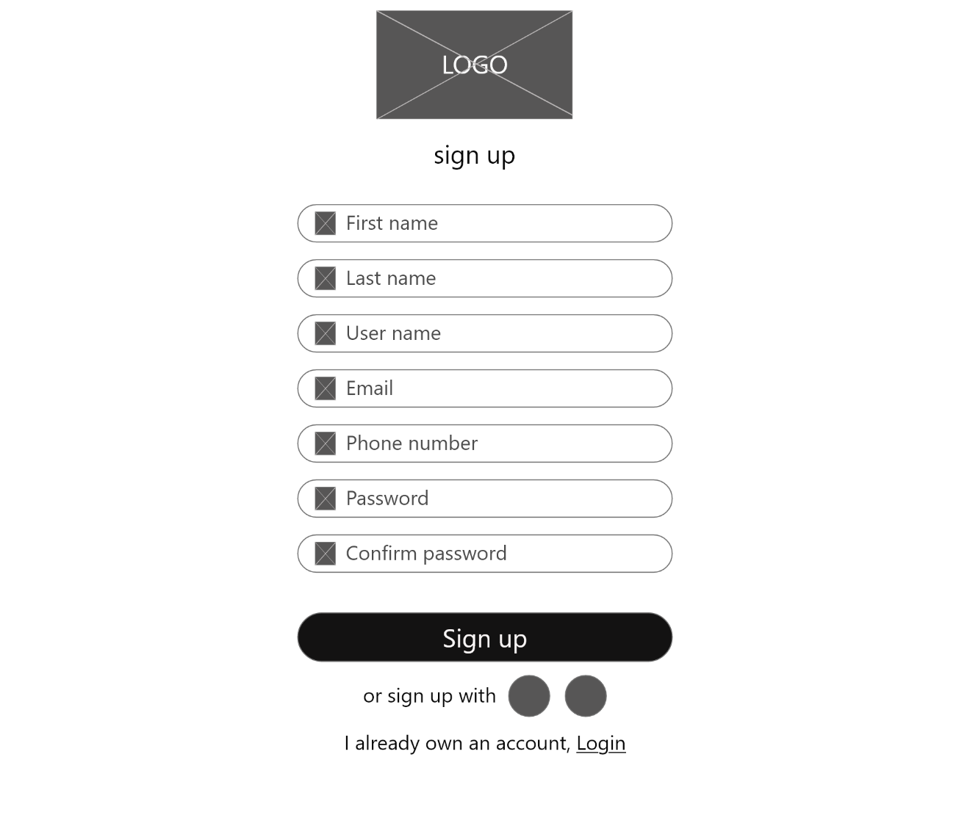

Figure sign up

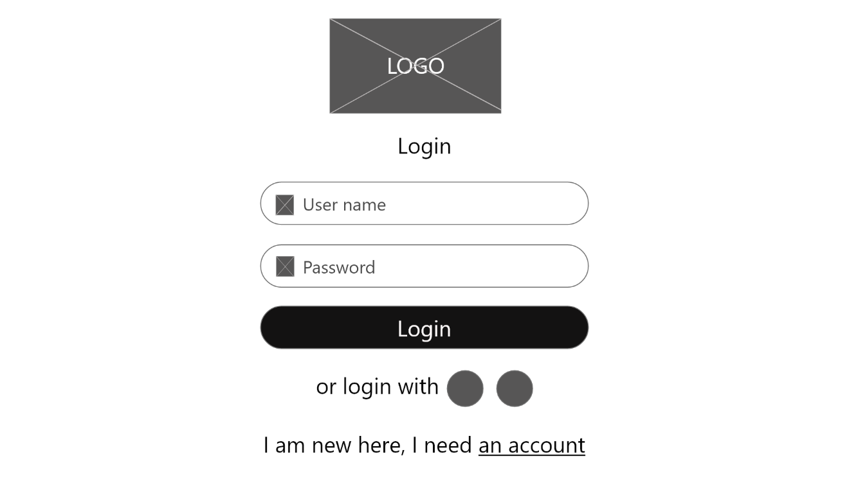

Figure Login

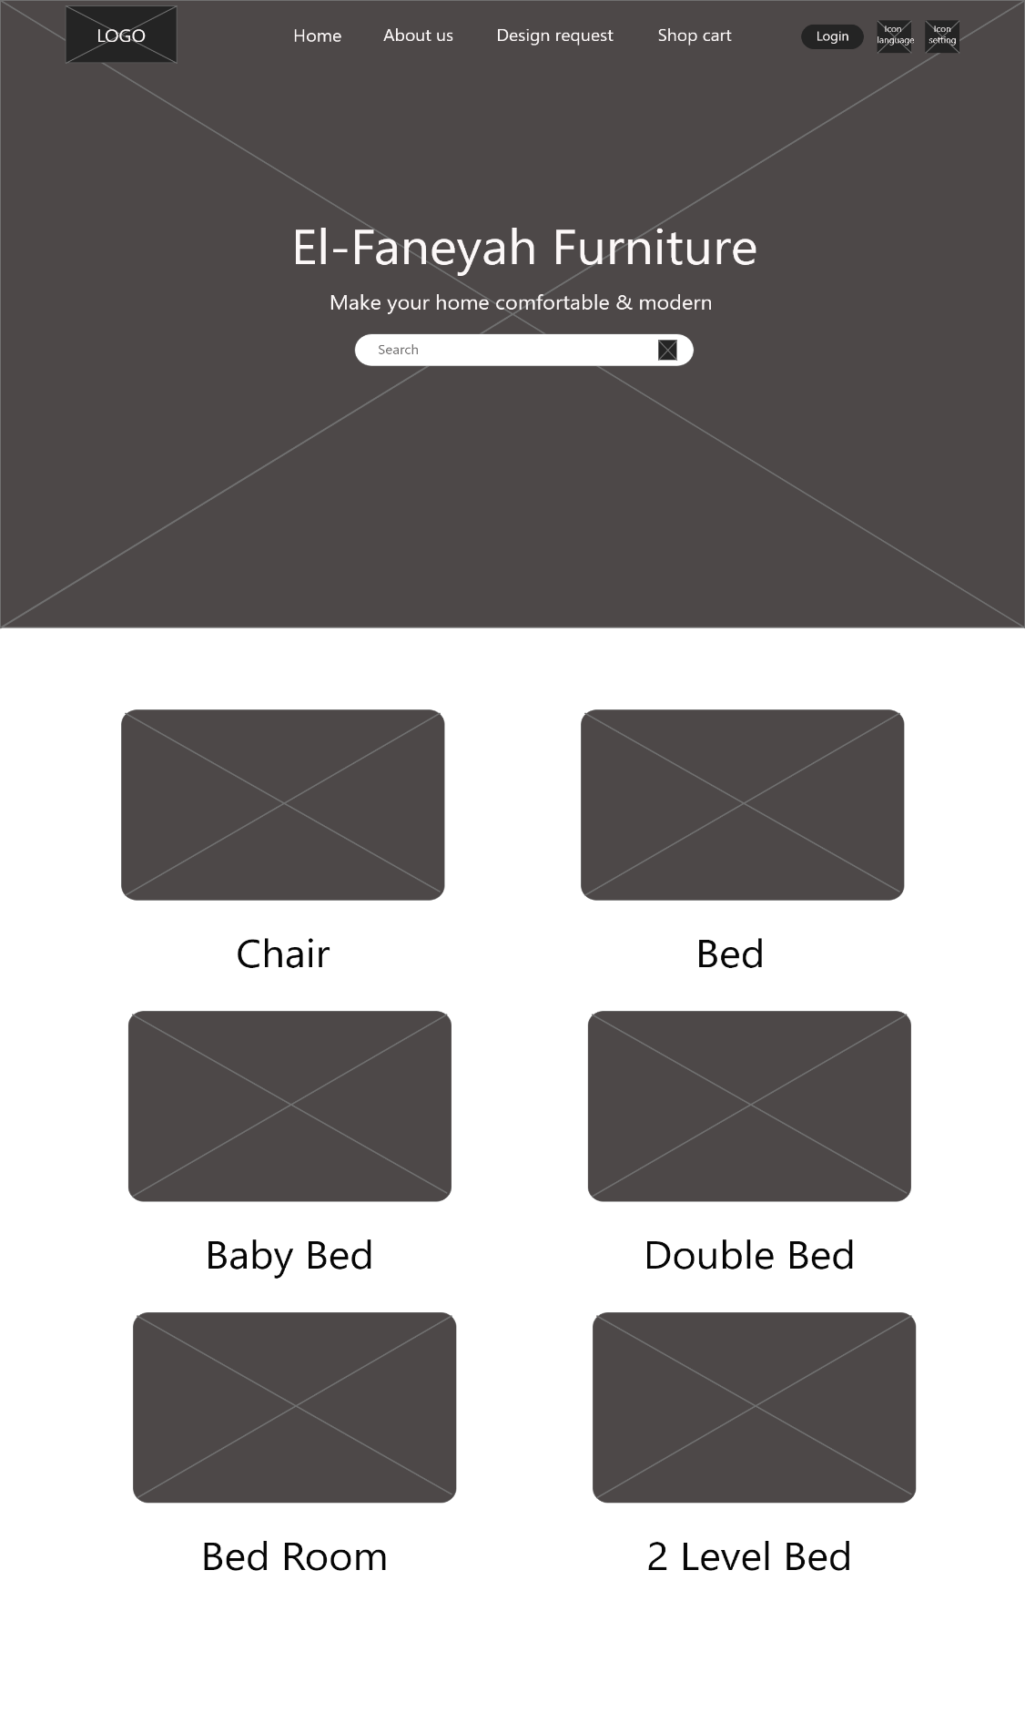

Figure Home page

### 

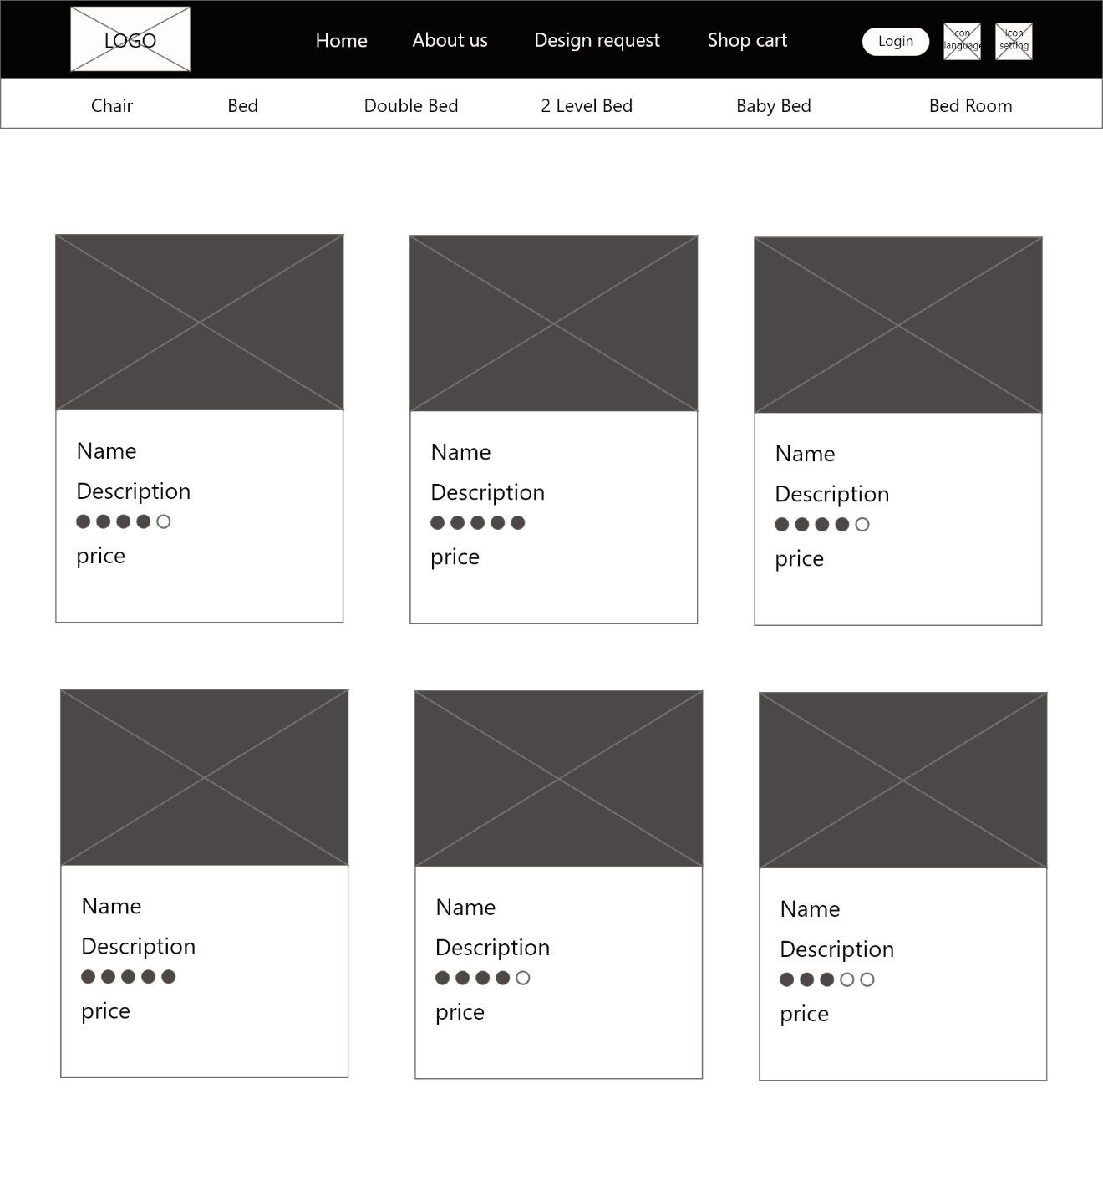

Figure Display Category and product

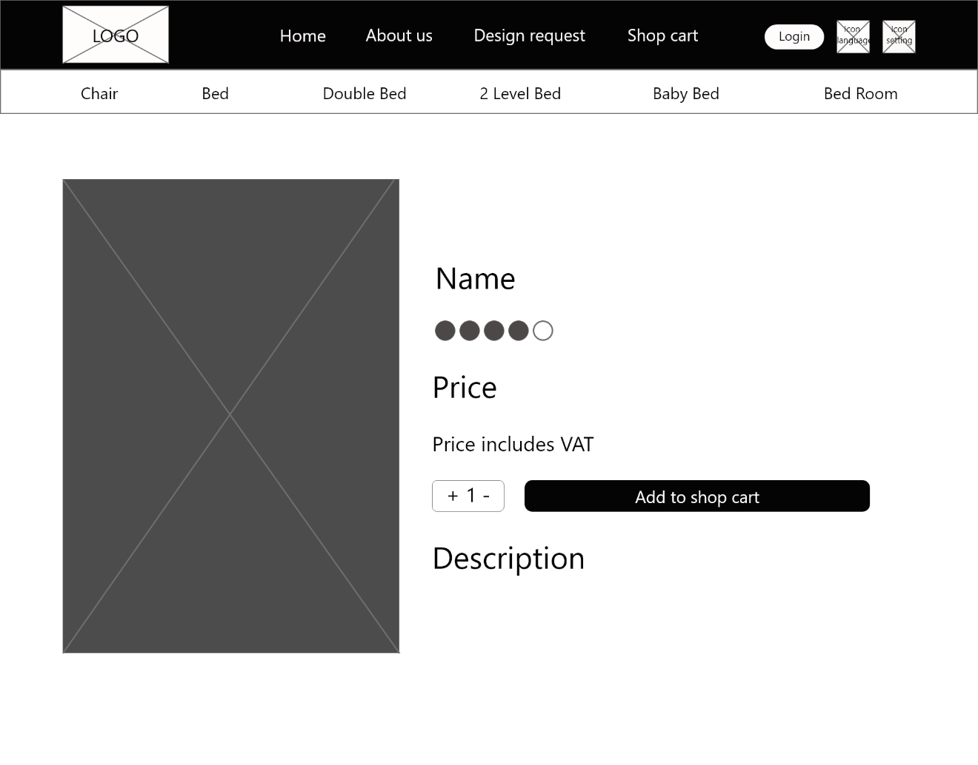

Figure Product details

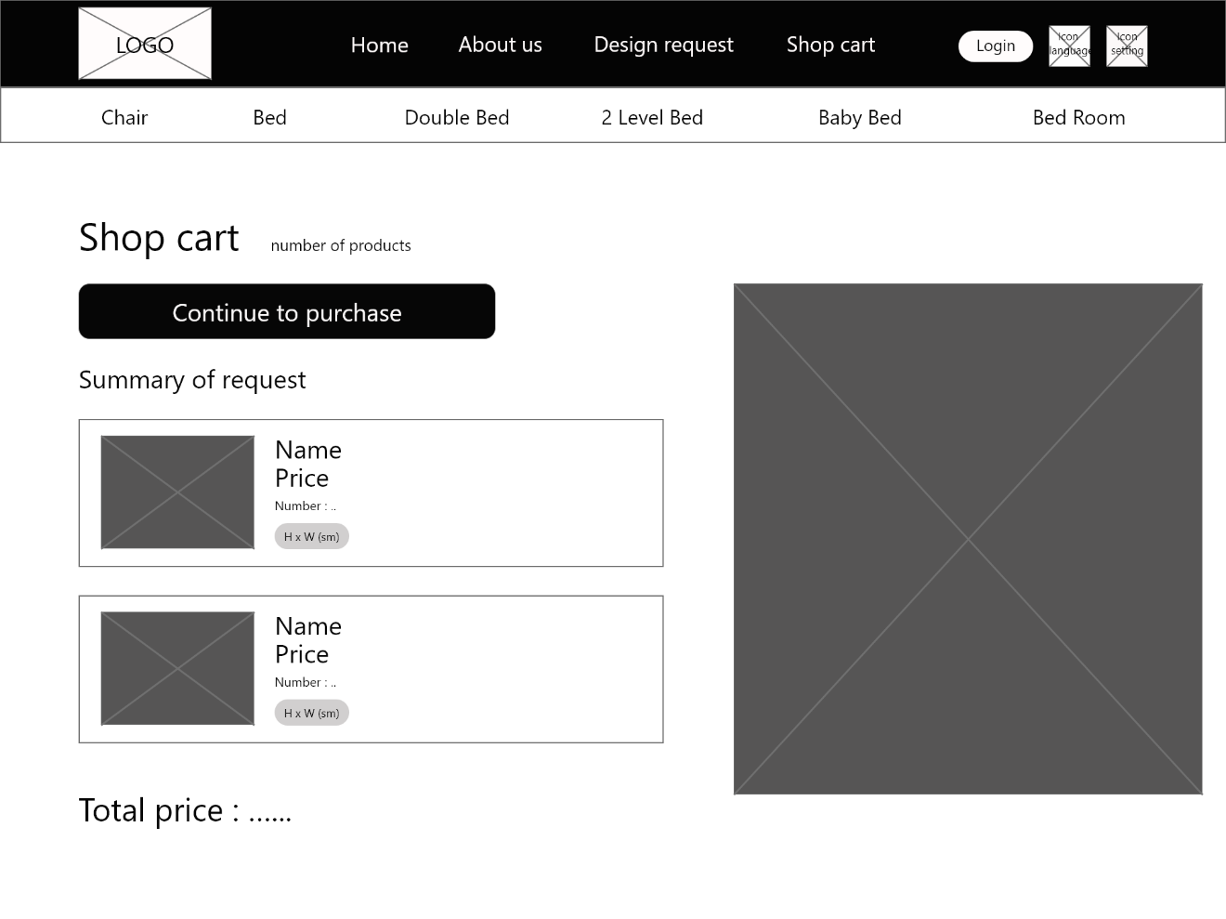

Figure Shop Cart

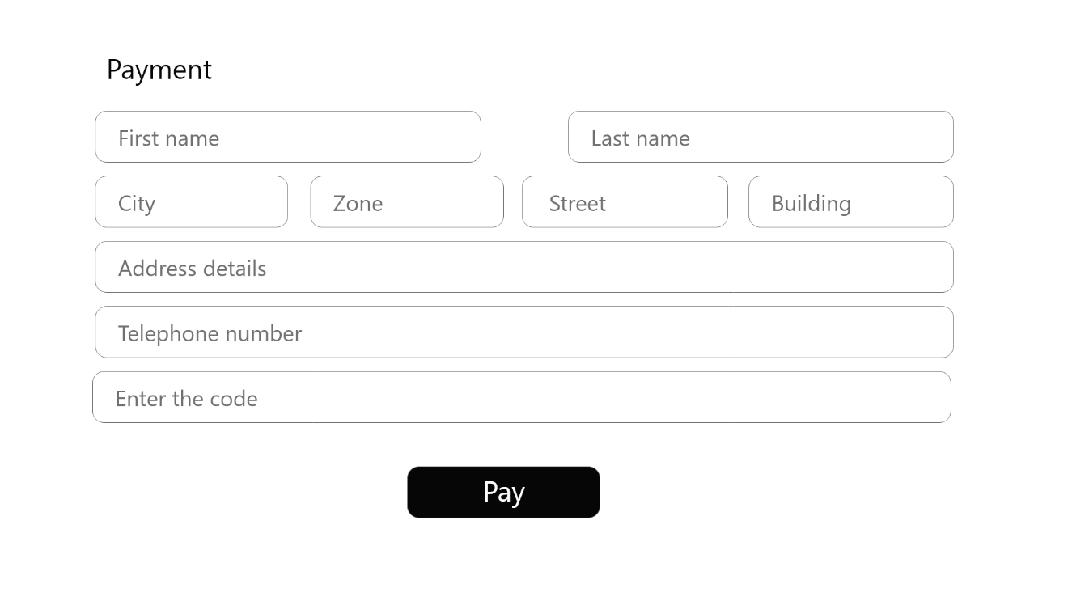

Figure Payment

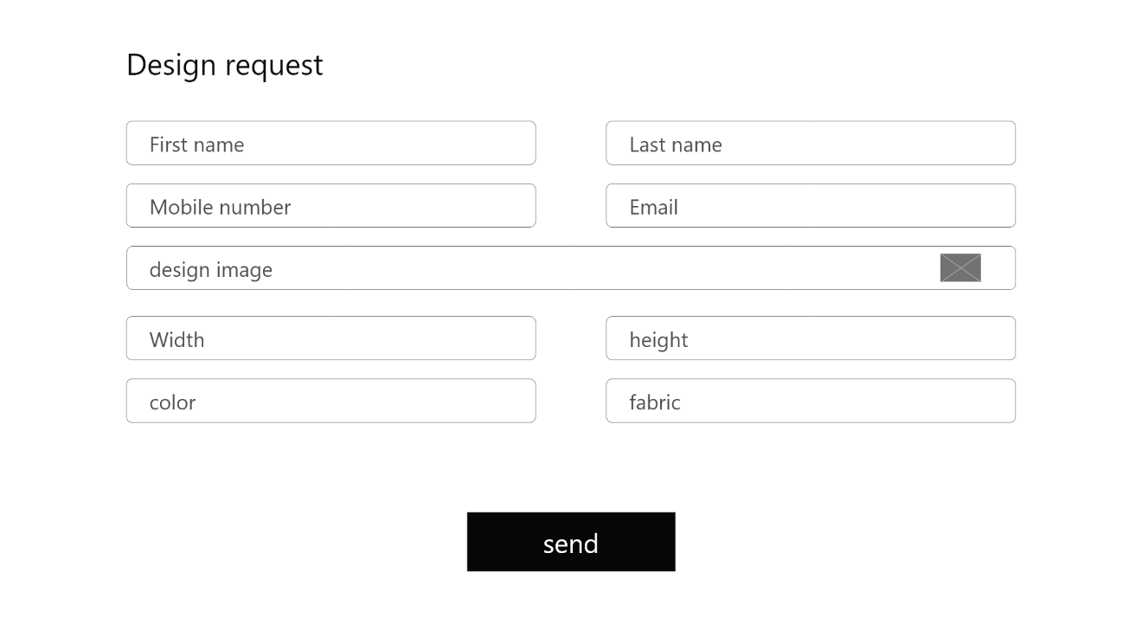

Figure Design request

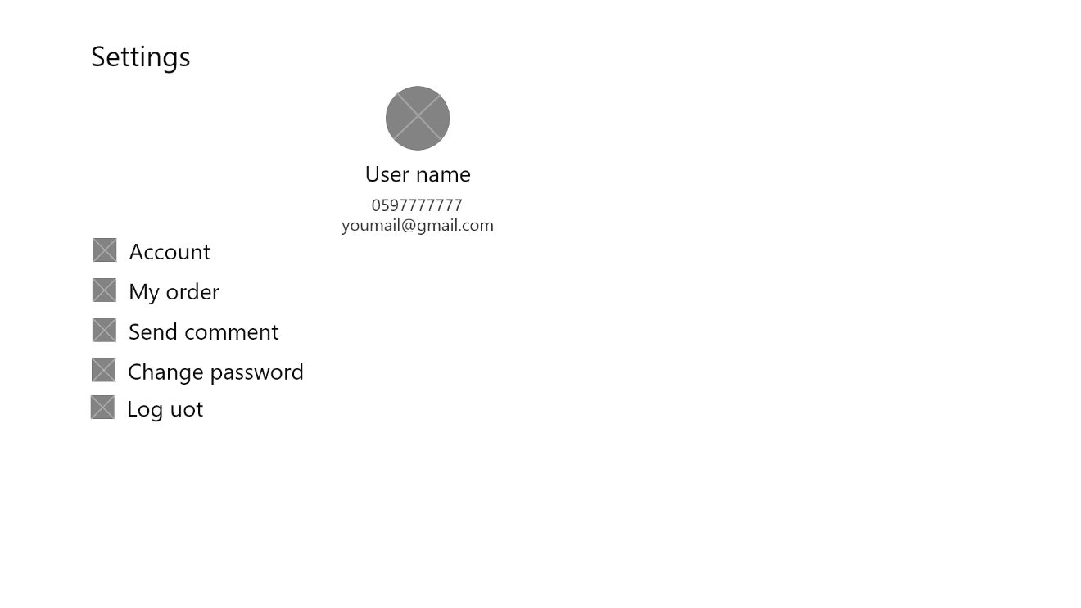

Figure Settings

### Admin Wireframes



Figure Login admin



Figure Sign up Admin

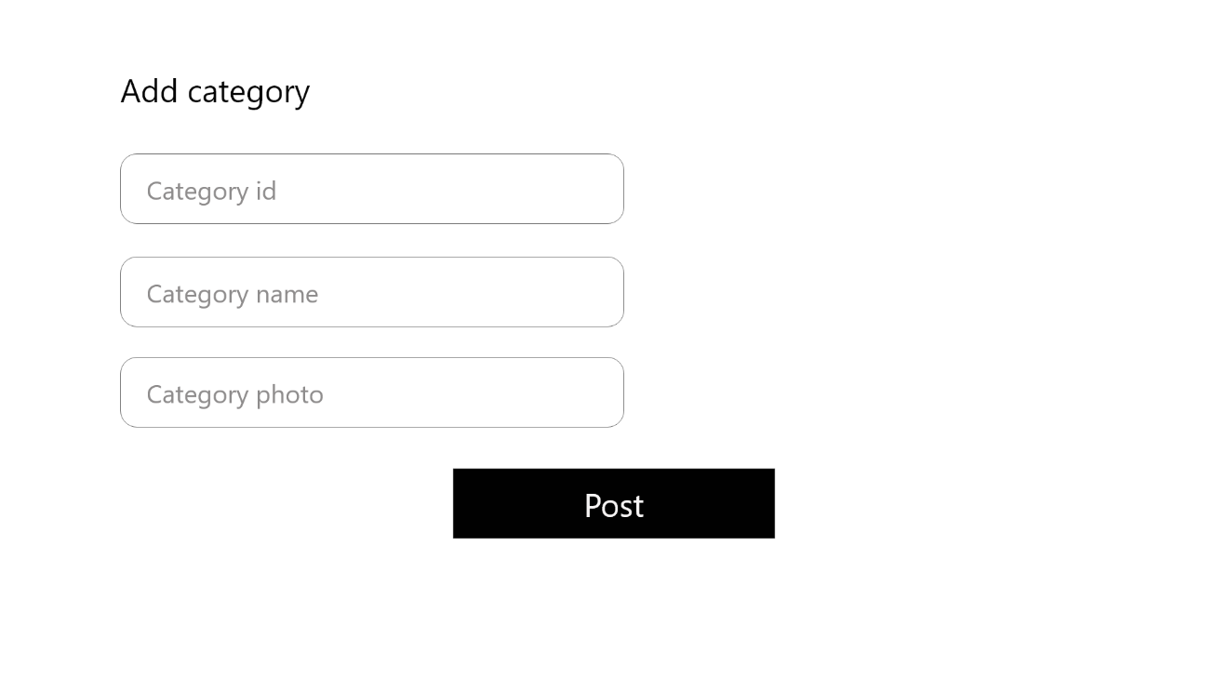

Figure Add category

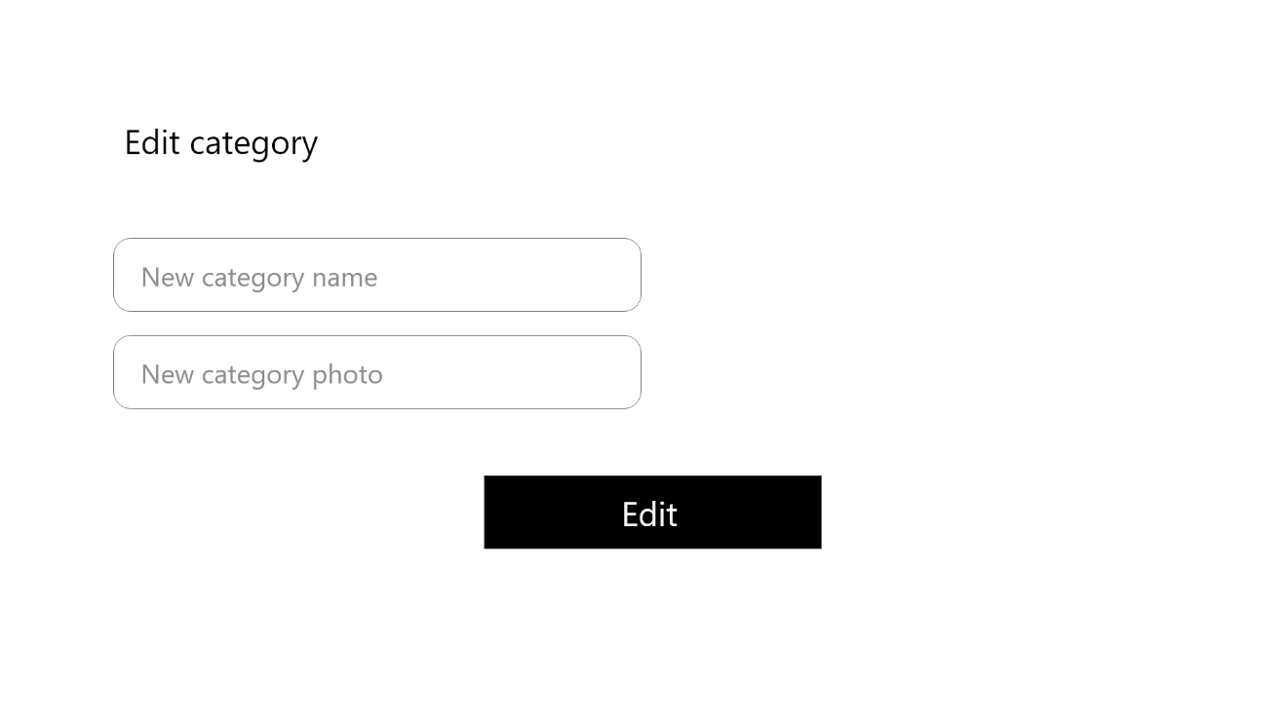

Figure Edit category

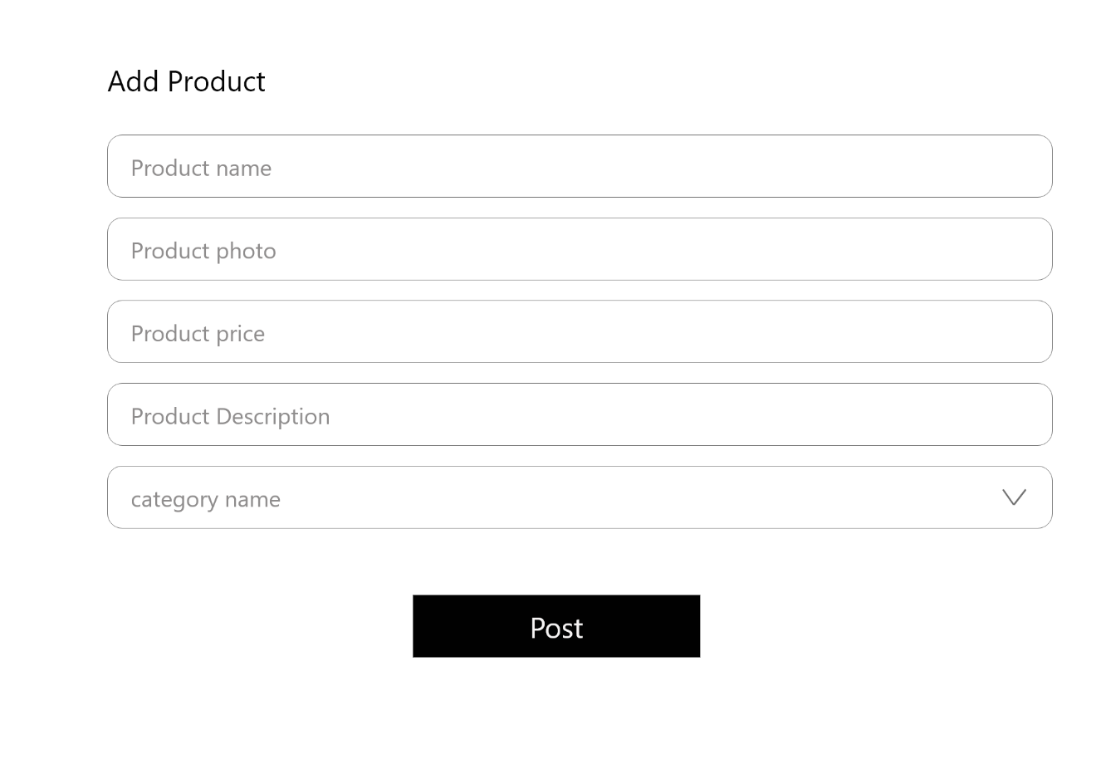

Figure Add Product

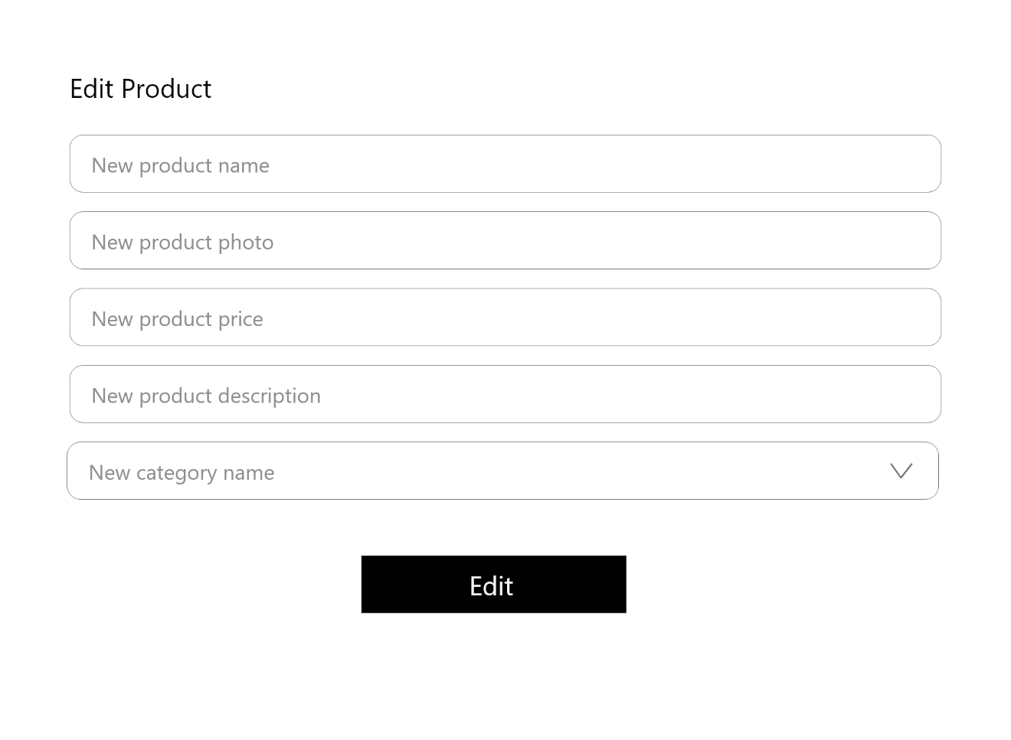

Figure Edit Product